**ALEX COSTIN**

**London, England (temporary) | alexcostin.com/contact | mail @ alexcostin.com**

Experienced digital marketing specialist skilled in research and data analysis, content creation, copywriting, design skills, paid advertising (PPC), website development, search engine optimization (SEO), social media management, email marketing, marketing analytics and critical thinking.

Enhance your online presence with technical tailored strategies aimed at reaching Google first page.

Reach new UK national clients and international markets in Europe, Asia, USA and South America!

**DIGITAL MARKETING EXPERTISE**

**MARKET, CUSTOMER AND COMPETITORS RESEARCH ANALYST** able to research all the market opportunities, customer behaviour trends and perform SWOT analysis on competitors, creating the most complex and successful digital marketing plans known.

- All research data gets sorted by importance and fed back to relevant decision takers.

**SEO SPECIALIST** with over 18 years’ experience in conducting SEO Audits to maximise SEO scores, defining content strategies, working with in-house teams to build SEO content.

- Performed tutorial sessions (remote and face to face) to train teams to be self-sufficient.

**CONTENT WRITER** that creates daily trending content which brings important Google impressions as well as traffic/customers to blogs, newsletters, and social media channels.

- I can create content (OFF PAGE backlinks) on personal websites to maximise a business ON-PAGE SEO rank, which draws the line between big market leaders and small websites.

**SEM MANAGER** with over 10 years’ experience in increasing (maximising) quality scores of paid campaigns, thus reducing PPC costs to a competitive minimum, whilst increasing ROI.

- Created strategies that through maximum Ads score (landing page + ad quality) resulted in reducing costs to just 10% of competitors average Cost Per Click (paying €0.2 instead of €2).

**GRAPHIC DESIGNER - PHOTOGRAPHER** which evolves brand identity potential and helps them fit in customers’ needs (branding, brochures, infographics).

- Shot high quality still life, ecommerce and studio photography for web and social channels.

**WEBSITE DEVELOPER / DESIGNER** that combines Drupal back-end with Bootstrap front-end to create perfect website which search engines love, without any penalties, on their highest ranks.

- Able to create "feeder websites" that will maximise OFF-PAGE SEO results and acquire new traffic and clients free of charge from search engines like Google, Bing, and others.

**SOCIAL MEDIA MANAGER** with access to own network of ~50,000 Twitter and ~1,000,000 Facebook fans where I can promote products organically to national/international markets.

- Managed and expanded influencer networks and set-up paid advertisement campaigns.

**PERFORMANCE SPECIALIST** that monitors daily Google Marketing Platform / Microsoft Advertising / Adobe Experience Cloud performance and provides key stakeholders with insights and new growth suggestions/ideas ranging from new markets to new channels.

**GROWTH DIRECTOR** able to target new markets and grow company portfolio of services or products. - - Ensured junior staff are guided in producing company's quality work.

**WORK EXPERIENCE**

**360’ Digital Marketing Expert** _________ 06/2015 - Current

**alexcostin.com** – UK / Spain / Italy / Romania / Russia / Canada / Germany / USA / France

* I meet with business owners, take notes of their goals, perform market research and competitor analysis to create elaborate marketing plans.
* I create brands, build perfect websites, SEO content, social media, paid ads and performance reports.
* I always achieve impressive results all over the EU for which I create Perfect Websites without any penalties, even with videos and sounds in them, and which with their maximum landing page quality enjoy maximum SEO results and decreased SEM (PPC) costs by up to 90%.

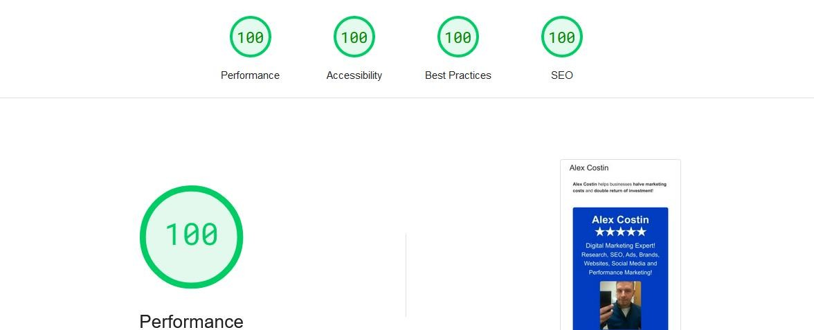

*I don’t change my CV to match job requirements, I don’t use a @gmail.com email address like all the other “experts”, but when it comes to technical expertise that search engines love and consider when ranking results, I am a 100% grade efficient, as confirmed by Google Web Performance* [*https://pagespeed.web.dev/*](https://pagespeed.web.dev/) *for* [*https://alexcostin.com/*](https://alexcostin.com/)*!*

“Unboxed 2022” **Digital Operations Manager** (*Contract*) 08/2022 - 11/2022

**Department for Culture, Media & Sport** – UK Government, Birmingham, United Kingdom

Overseeing the day-to-day operations of digital teams, ensuring smooth functioning of digital services:

* Managing Team Operations: Responsible for managing the day-to-day operations of the team, including communication, project oversight, and team building.
* Performance Monitoring: Ensure that business benchmarks are met through detailed reports and analysis, focusing on areas like inventory availability and site improvements.
* Cross-Functional Collaboration: Collaborate with various departments like Content, Social Media, Creative, and Photography teams to drive website visitors and site enhancements.
* Training and Mentorship: Train new colleagues and mentor existing team members on necessary skill sets to ensure team effectiveness and project delivery goals.
* Problem-Solving: Troubleshoot daily process and system issues to maintain operational efficiency.
* Process Improvement: Identify areas for process improvement across all brands, and establish strategies for enhancing operational efficiency.
* Quality Assurance: Conduct regular QA checks on the project website and drive improvements through continuous monitoring.

**Marketing Manager** (*Full Time*) 10/2021 - 01/2022

**Away Days** corporate events – London, United Kingdom

* Strategic Planning: Developing and implementing marketing strategies to promote products or services effectively.
* Campaign Management: Overseeing the creation and execution of marketing campaigns across different channels like advertising, email, events, and social media.
* Budget Management: Developing and managing budgets for marketing activities, ensuring cost- effectiveness and profitability.

**Marketing Manager** (*Full Time*) 02/2020 - 03/2020

**WorkPad** luxury office rental – London, United Kingdom

* Market Research: Conducting market research to identify new markets, customer preferences, and trends to enhance product sales and profitability.
* Content Strategy: Setting content strategies and overseeing the creation of engaging content for various marketing channels like websites, blogs, and social media.
* Performance Analysis: Analysing data to evaluate the success of marketing campaigns, tracking ROI, and refining strategies for improved brand exposure.

**Digital Marketing Specialist** (*Contract*) 06/2019 - 11/2019

**Elemental One** digital agency – Barcelona, Spain

* Responsible for enhancing brand awareness, driving traffic, acquiring leads through digital channels and website rebuilds for Blue Night Barcelona entertainment venue, Bit Base Spain cryptocurrency exchange and others.

**PPC Specialist** (*Contract*) 05/2019 - 05/2019

**Needen France** ecommerce marketplace – Paris, France

* Researched and set up pay-per-click Microsoft advertising campaign to drive targeted traffic and conversions.

**Digital Marketing Project Manager** (*Contract*) 06/2018 - 07/2018

**Promote.Barcelona** digital agency– Barcelona, Spain

* Overseen the marketing project from start to finish, ensuring timely execution and successful delivery of the digital marketing agency website.

**Google AdWords / Ads Partner** (*Full Time*) 04/2017 - 04/2018

**Google Ads** – London and Barcelona

* Google Partners are experts in Google Ads, possessing the knowledge and skills to optimize campaigns effectively, ensuring that marketing efforts are rewarded and companies reach maximum ROI.
* Clients included a £1 000 000 monthly car insurance supplier that benefited of an 8% ROI increase!

**EDUCATION**

* **BSC Multimedia Computing**: Coventry University, United Kingdom
* **Google Marketing Platform**: Google, United States of America
* **Microsoft Advertising**: Bing/Microsoft, United States of America
* **Adobe Experience Cloud**: Adobe Business, United States of America

**FOREIGN LANGUAGES**

**International Baccalaureate** graduate and **Foreign Language BSC** diploma (distance learning):

* **C1 level** English, French, Italian and Spanish
* **B1 level** Catalan
* **A1 level** German and Portuguese